# **Assembly Instructions for the 4Tronix Bit:bot**

**These instructions are a reproduction of those on the 4tronix.co.uk website and are only used to support students that do not have access to the company’s website**

**Parts list**

1 caster assembly (either metal ball or plastic ball)

2 × 6mm M2 pan head screws (now already fitted)

2 × M2 nuts (now already fitted)

2 × 12mm brass pillars

4 × 8mm M2.5 countersunk screws

1. Use the M2 6mm (panhead) screws and nuts to attach the front caster housing, then push the caster ball into the housing
2. Use the M2.5 6mm panhead and 8mm countersunk screws to fit the battery pack onto the 2 metal pillars: **ENSURE the on/off switch is at the rear of the Bit:Bot**
3. Push the wheels on with the smooth side outwards. The axle should come flush with the outside of the wheel and not protrude (or the inside can catch on the motor housing)
4. Push your BBC micro:bit into the edge connector with the **LEDs and switches on the top**

[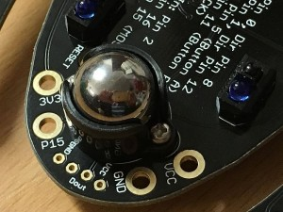](http://4tronix.co.uk/blog/wp-content/uploads/2016/12/Step5.jpg)

**Battery Holder**

1. At this point you should have 4 screws left. Either 4 × 8mm countersink, or 2 × 6mm panhead and 2 × 8mm countersink.
2. If you have the 6mm panhead screws, use these to fit the 12mm brass pillars to the Bit:Bot main PCB.
3. Always use 8mm countersink screws to fit the battery holder to the brass pillars.

[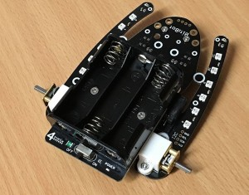](http://4tronix.co.uk/blog/wp-content/uploads/2016/12/Step7.jpg)

**Fit the Wheels**

Push the wheels on, so that the axle is flush with the outside of the wheel

[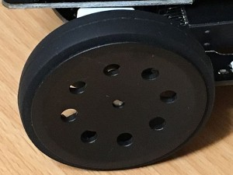](http://4tronix.co.uk/blog/wp-content/uploads/2016/12/Step8.jpg)

**Attach the Micro:bit**

[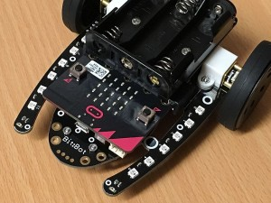](http://4tronix.co.uk/blog/wp-content/uploads/2016/12/Step9.jpg)

**Know your Bit:Bot**

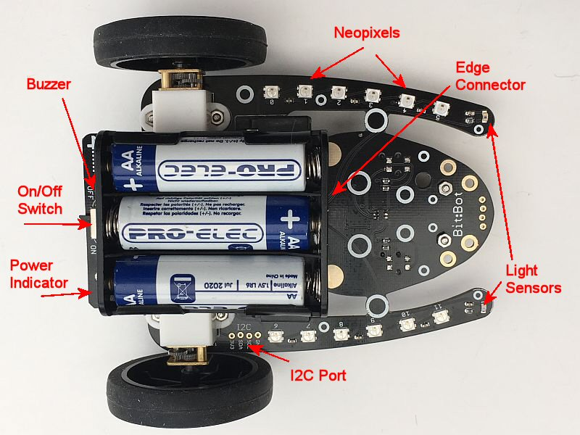

[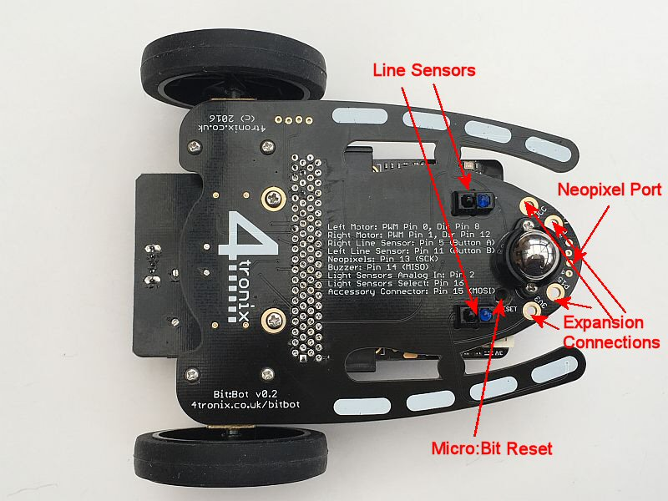](http://4tronix.co.uk/blog/wp-content/uploads/2016/12/bb15a.jpg)